Yoga with Love Adventure Yoga
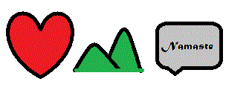

Your signature below as a yoga student of Michele Snow, Teddi McEwen & Love Adventure Yoga , is acknowledging that participation in Yoga may result in accident or injury and you assume the risk connected with the participation in Yoga and you represent that you are in good health. Participant acknowledges that Michele Snow, Teddi McEwen & Love Adventure Yoga has not and will not render any medical services including medical diagnosis of Member’s physical condition. Additionally, you specifically agree that Michele Snow, Teddi McEwen & Love Adventure Yoga or its officers, employees and agents shall not be liable for any claim, demand, cause of action of any kind resulting from or related to the use of the facilities or participation in any sport, exercise or activity within or without the location’s premises, and agrees to hold Michele Snow, Teddi McEwen & Love Adventure Yoga harmless from shame.

I have read the above release and waiver of liability and fully understand its contents.

Participant Name (print) _____________________________________

Participant Name (sign)____________________________________

Telephone #____________________________________________

Date______________________

